Lab 1 Digital Signal Processing

Rahma AbdulHameed 7358

Student Experiment #1

a) Define and stem the signal x[n] where:

x[n]=2 at n=0, 1 at n=2, -1 at n=3, 3 at n=4, 0 otherwise

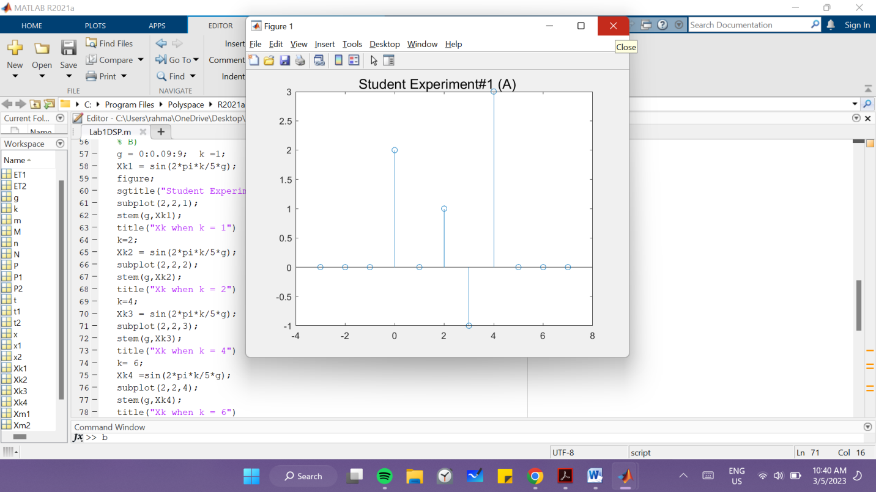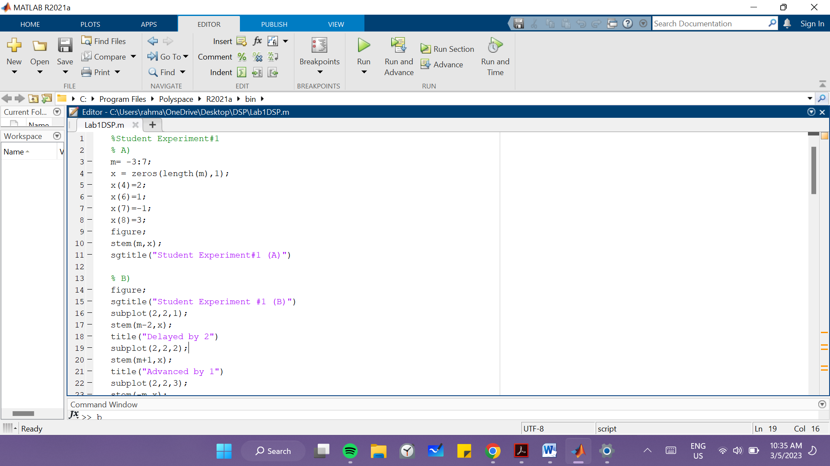Draw it from n= -3 → 7

b) Draw the following signals by defining the new axes:

y1[n]=x[n-2]; %delayed by 2 samples

y2[n]=x[n+1]; %advanced by on sample

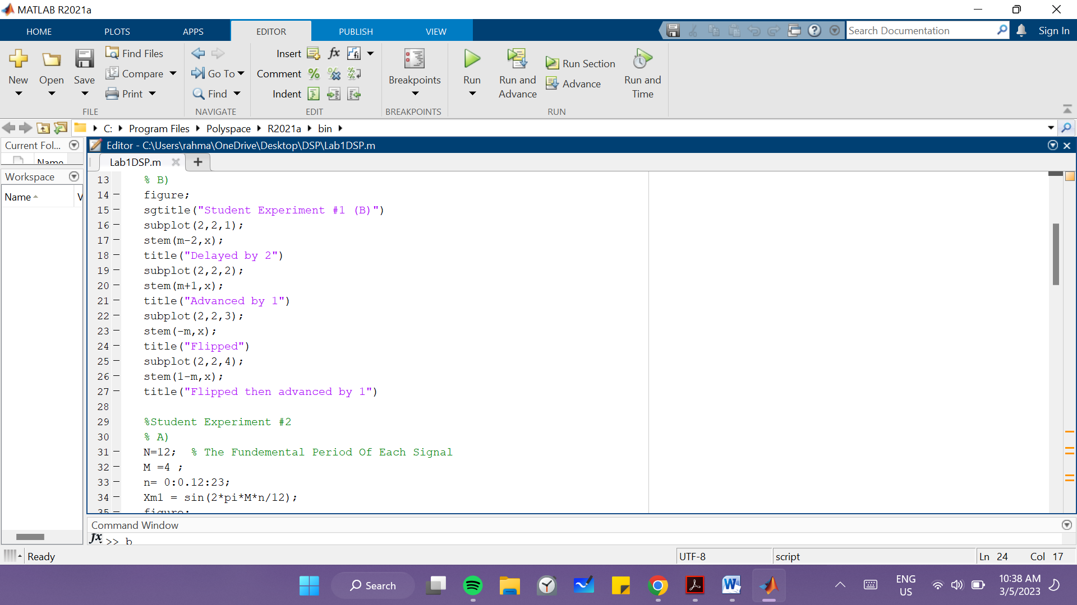y3[n]=x[-n]; %flipped version

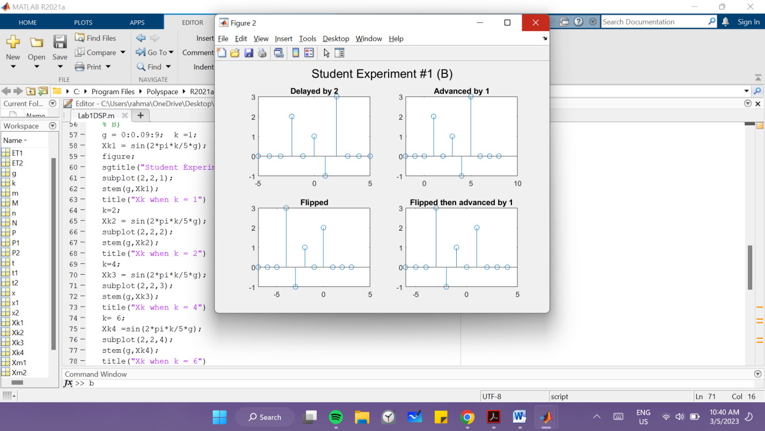y4[n]=x[-n+1]; %flipped then advance

Student Experiment #2

a) Consider the discrete time signal

Xm[n] =sin (2\*pi\*M\*n/N)

And assume N=12. For M=4, 5, 7 and 10, plot Xm[n] on the interval n=0→2N-1.

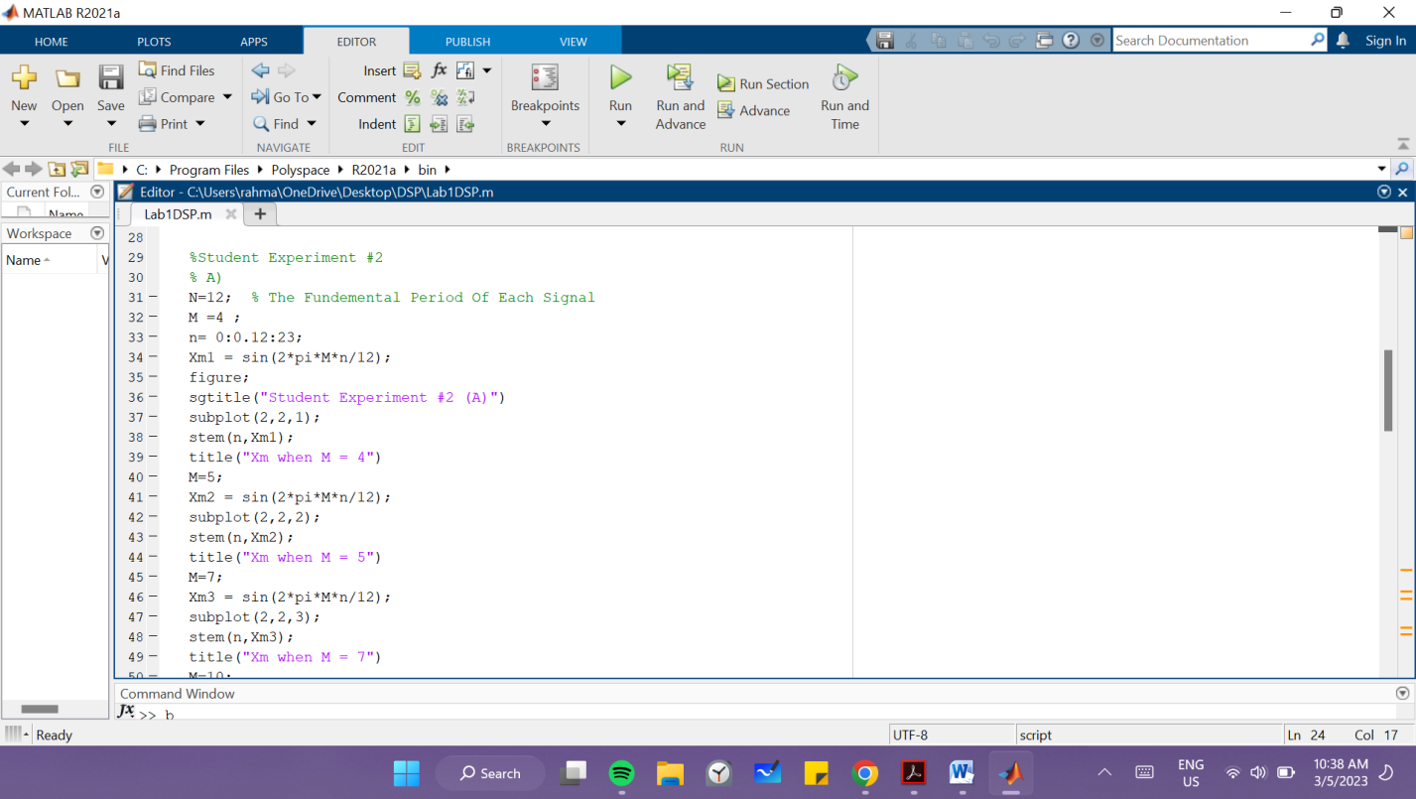What is the fundamental period of each signal?

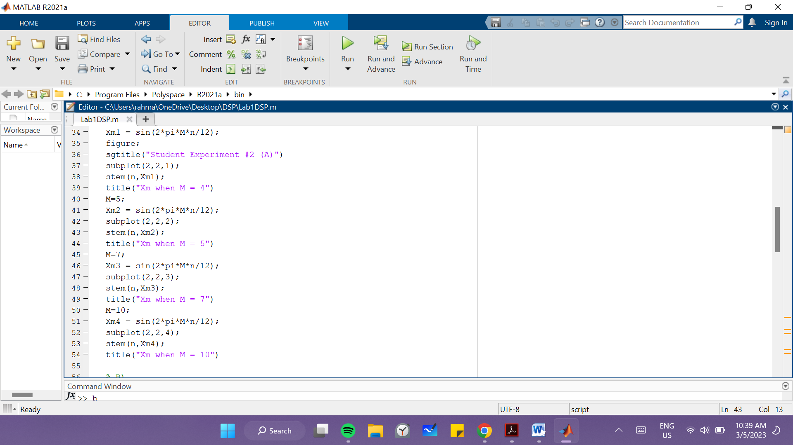

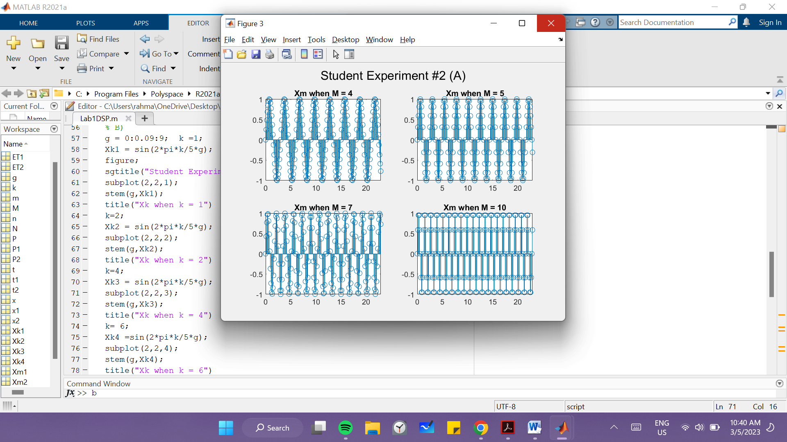

b) Consider the signal: Xk[n] =sin (wk\*n),Where wk=2\*pi\*k/5. Stem Xk for k=1,2,4,6 from n=0→9 in one figure using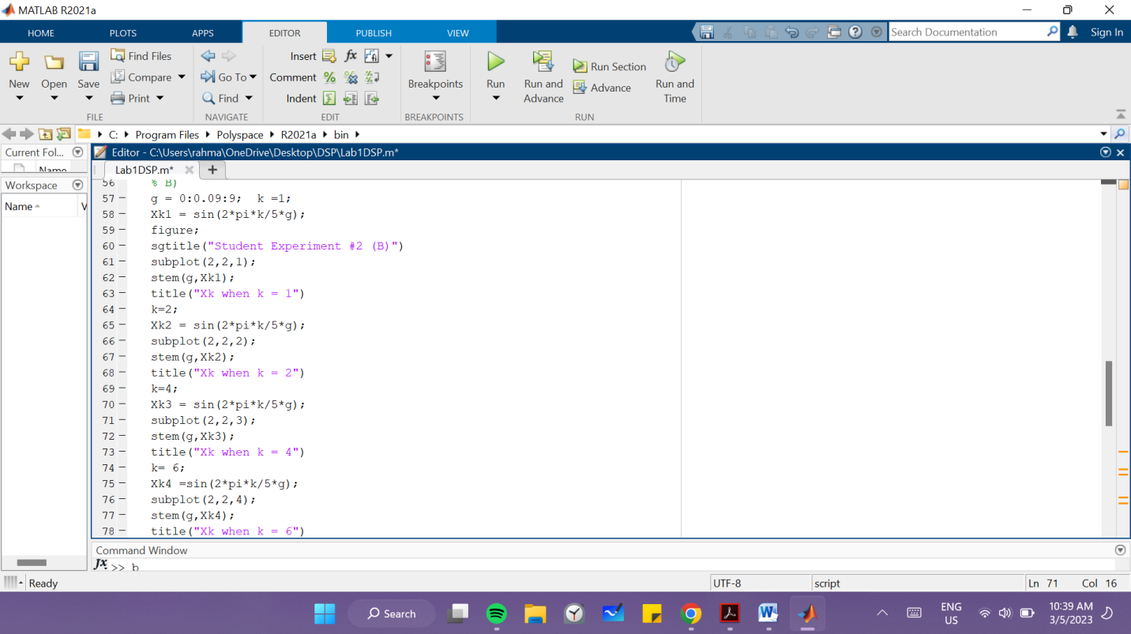 the subplot command.

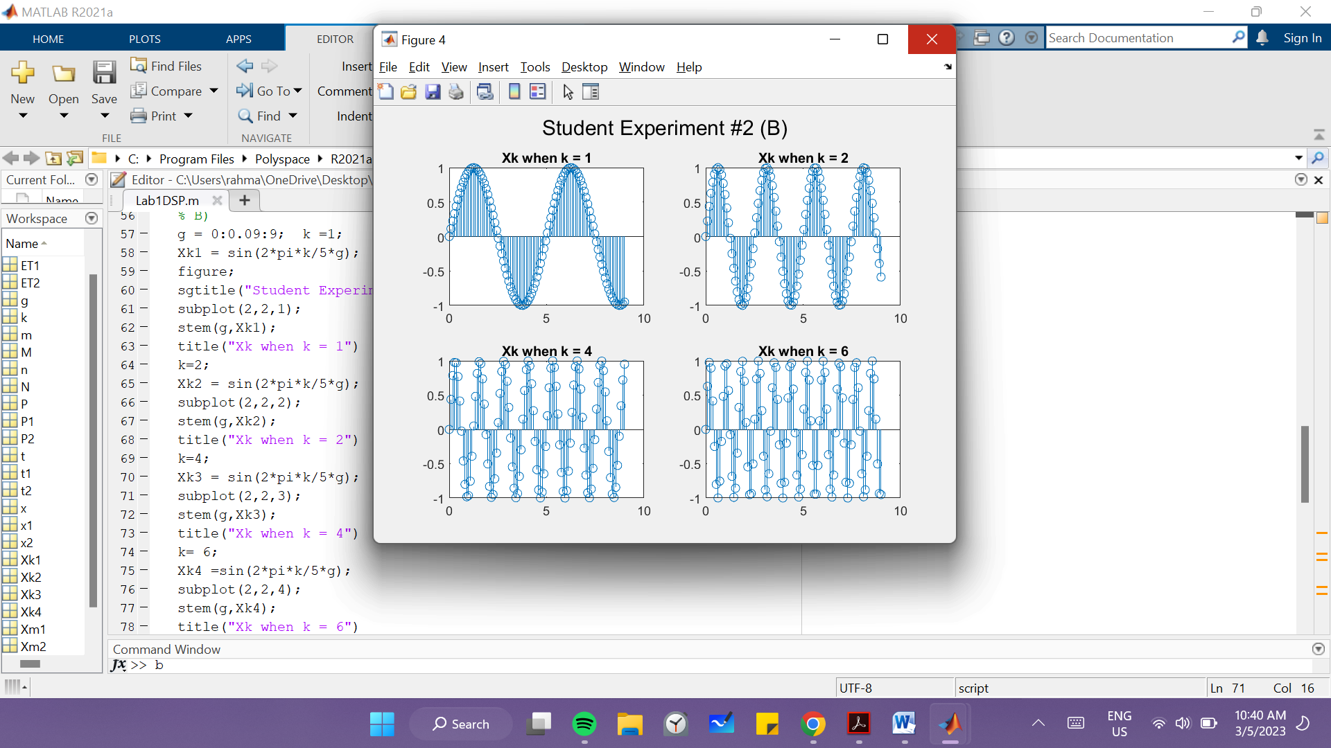

Student Experiment #3

a) Define a sinusoidal signal with period = 10, stem it and calculate the power of

this signal

b) Define the above signal from n= 0 →12, calculate the energy of the

signal, calculate its power. Compare it with the result in (a)

c) Define the signal from n=0 →1005, calculate the energy of the signal, calculate

its power. Compare it with the result in (a) Comment on your observations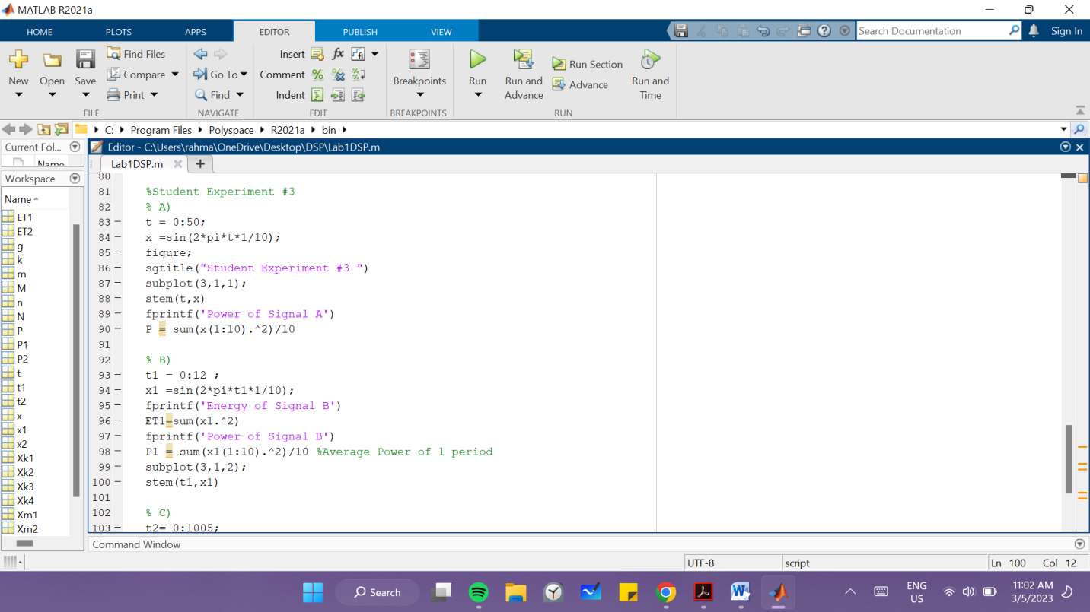

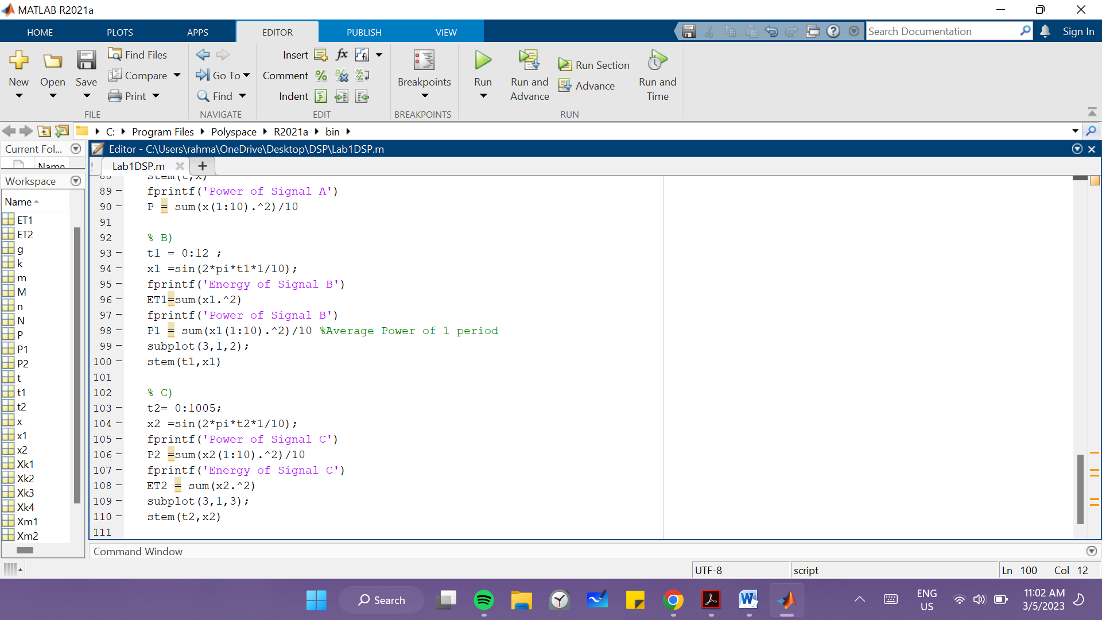

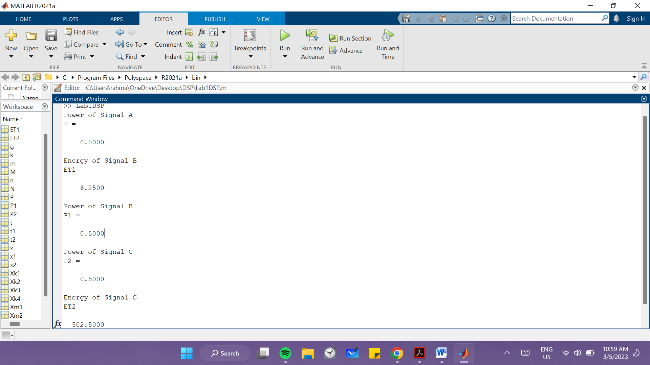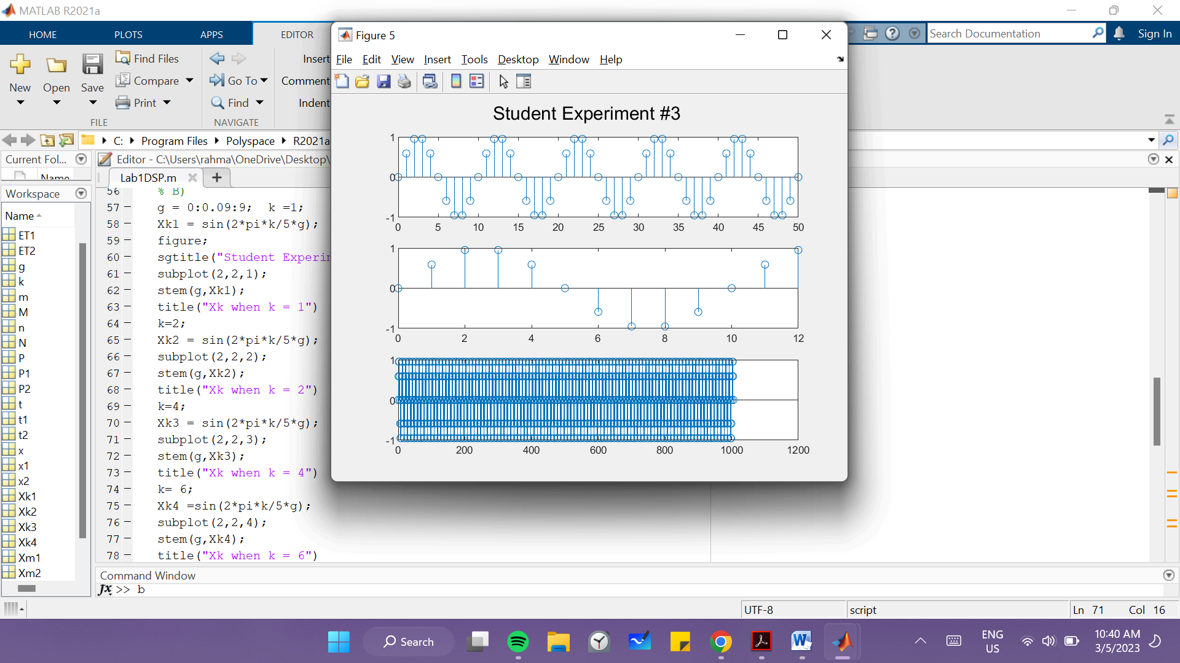

Comment:

The power doesn’t change because the value of power of a periodic signal is the same as the value of the power of 1 period of that same signal